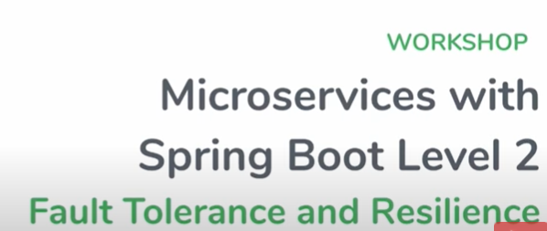

Fault Tolerance simply means **a system's ability to continue operating uninterrupted despite the failure of one or more of its components**.

**What is microservice resilience?**

Resilience of a Microservice Architecture System is **the ability to maintain the performance of services at an accept- able level and recover the service back to normal, when a disruption causes the service degradation**

**What is fault tolerance in microservices?**

Fault tolerance is **a property that keeps the system operational even after failures in some components**. Also, a property can mean any of these – Microservices, Database, and Load Balancer

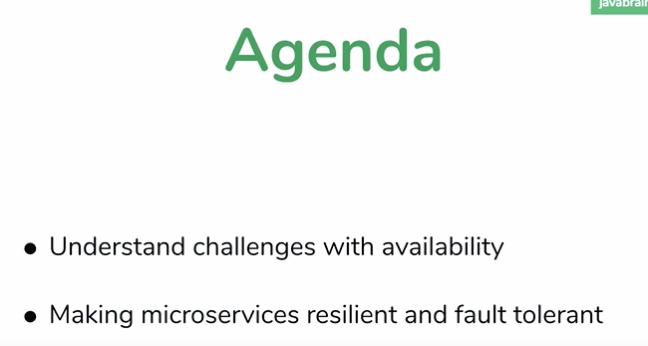

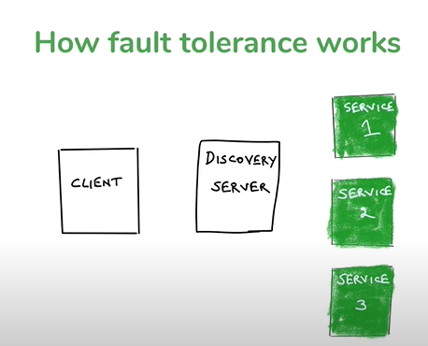

Means service is down . It will keep sending heart to service discovery which occur by default

**NOTE** if service goes down it will get it from cache from eureka server and all it will done by eureka server

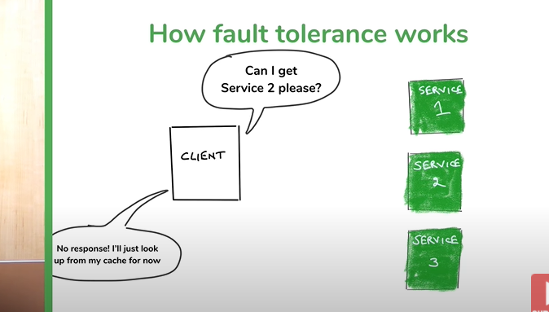

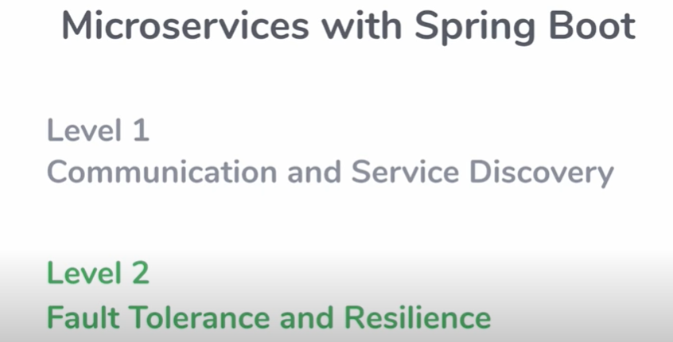

**fault tolerance**

For a given application if there is a fault , what is the impact of that fault.

How much the tolerance does that system have for a specific fault.

What tolerance does that system have for fault is called **fault tolerance**

**Resilience**

**Resilience :** how many fault that system can tolerate

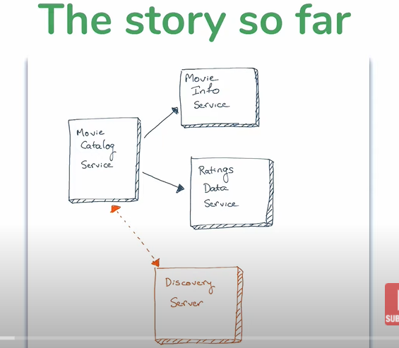

**One change in code**

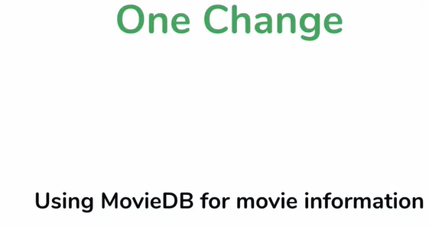

**Problem 1 :-------------------What if microservices goes down**

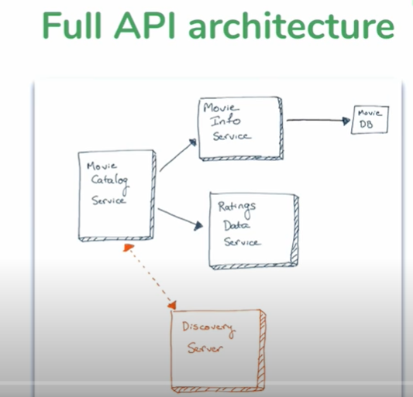

**This architecture is not fault tolerant if any service goes down, then whole application will go down**



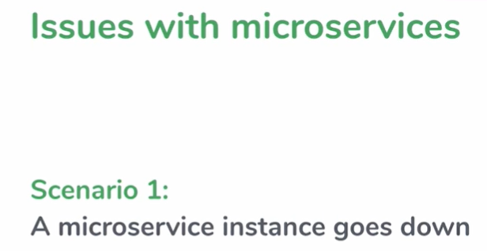

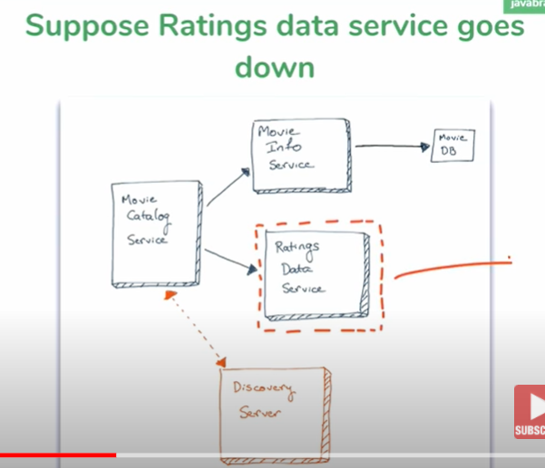

**Solution**

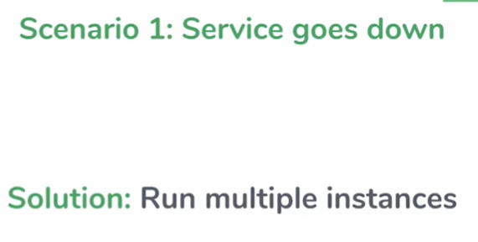

**Solution**

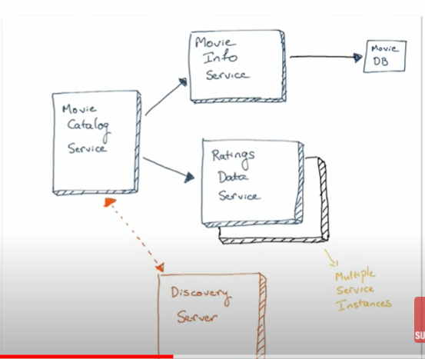

**Service discovery registered automatically we don’t need to register it**

Ribbon is **a client-side load balancer that gives you a lot of control over the behavior of HTTP and TCP clients**. Feign already uses Ribbon, so, if you use @FeignClient , this section also applies. A central concept in Ribbon is that of the named client.

Client side load balancing technology called ribbon and what it does, it does round robin , if it

See more than one instance , I call this microservice last time so I need to call this one this time

. It will do equal distribution of load

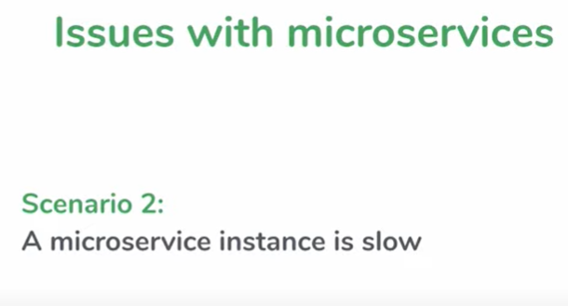

Bigger problem : if microservice Is slow

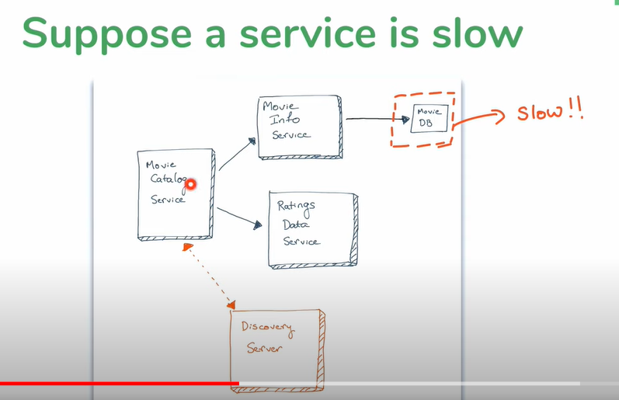

If movie db is slow then movie info service is slow so any api which is calling other one which is slow then first one also will be slow.

Ex: movie catalog service will be slow if movie db info which we are getting from url is slow since movie info service is depend on movie db

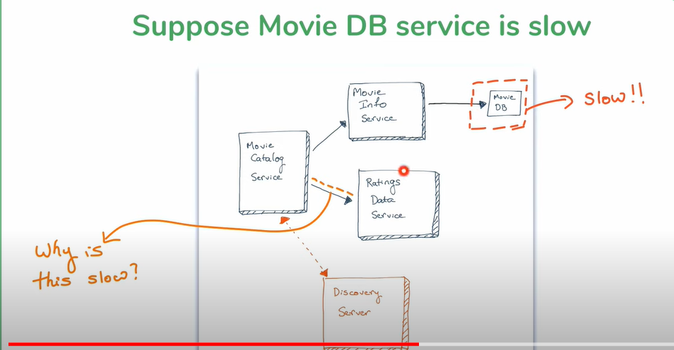

**NOTE: query is : how is unrelated service will be slow**

**Movie catalog service is depend on both service but other two service are independent of each other**

**Answer : thread**

**Problem with thread sb m/s**

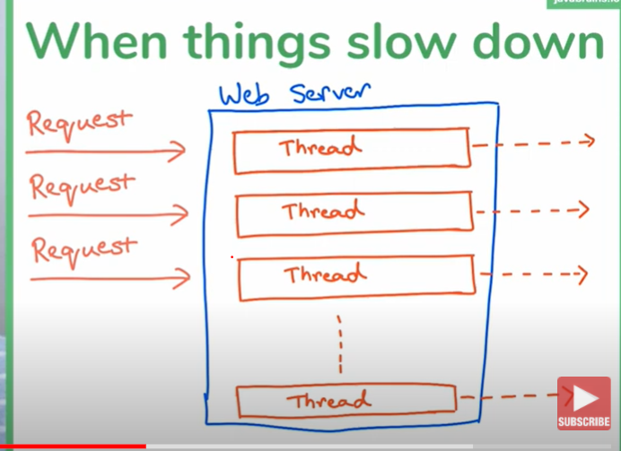

**Too many request coming in and all thread consumes means reaches thread count then in this way it will become slow and the thread not cleared out quickly from web server**

**See in terms of microservices**

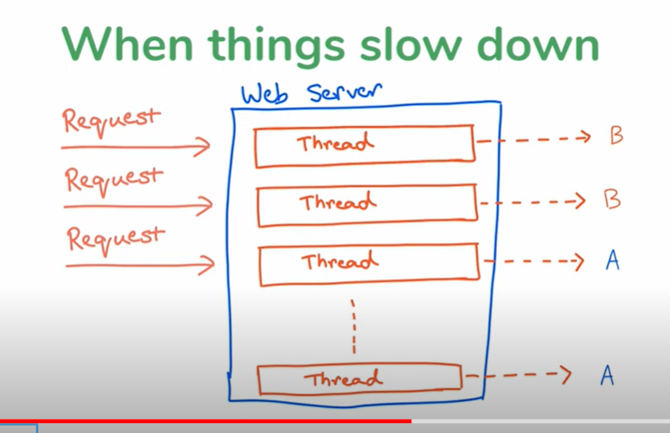

**A and B--- M/S**

**So here request for B thread is coming then it has to wait since b Is slow and A ms will finish fast soon thread of B will be more and it will reached maximum count of thread then now request will come for A then it has to wait in this way M/s which is not related to each other has to wait**

**This is the problem happening with our scenario**

**Possible solution for slow m/s**

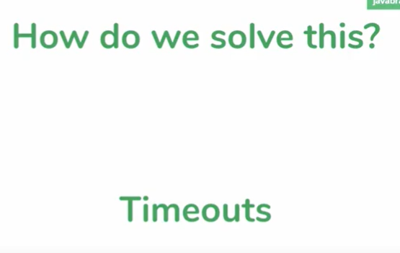

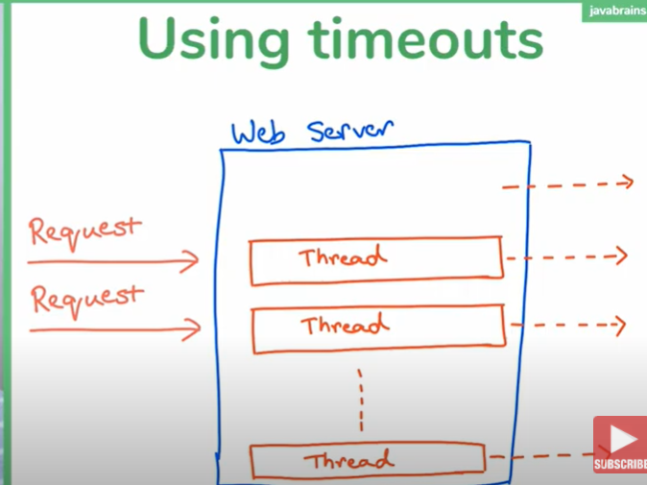

**Using timeout we are removing the m/s which taking more time**

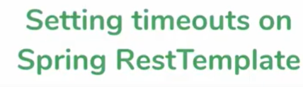

**Note: this is not preferred way.**

**Adding timeout to rest template**

**Note : restTemplate takes a argument where we can set timeout**

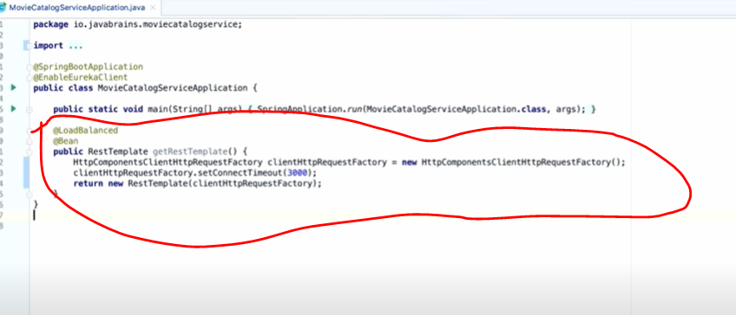

**Does this solve the problem**

**Note : if frequency of request i.e more than time timeout means**

**Request -----per second**

**Timeout ------ 3 second**

**Then again will reach same place means we will run out resources**

**Note: it will solve problem as long as request is coming and thread removed timeout is lesser that time request hitting**

**So timeout kind of solve the but not fully solve the issue**

 Understanding the circuit breaker pattern

Step -1

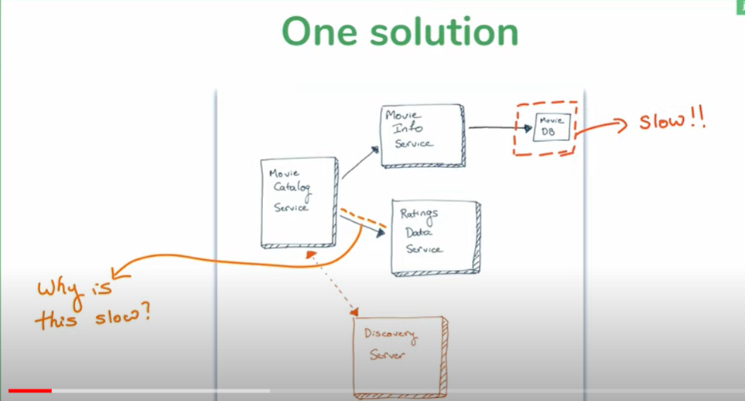

Because of above one (movie db) consuming all resources

**Step 2**

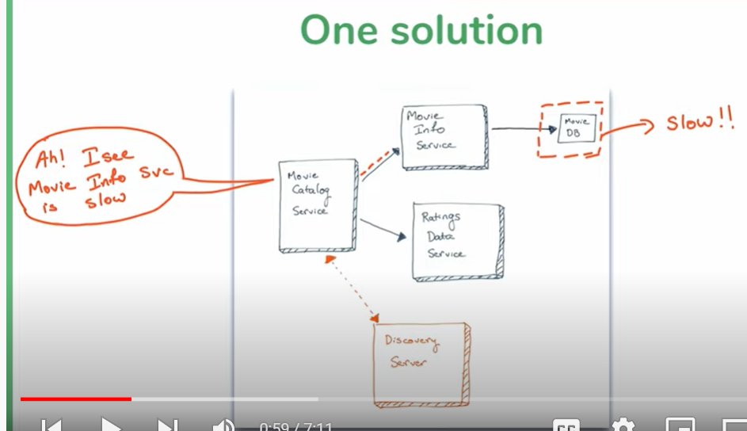

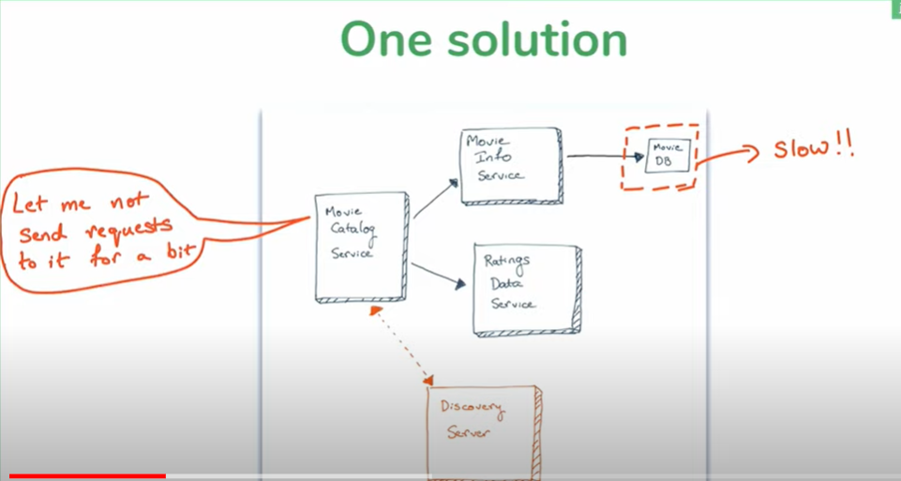

**One solution:**

if some m/s is slow then don’t send request from other m/s.

Wait for some time and then send request again if it is recovered then send request continuously.

Note: this is popular pattern for fault tolerance in m/s

1. m/s calling another m/s has the ability to detect something is wrong
2. m/s will take temporary step and stop sending request to m/s

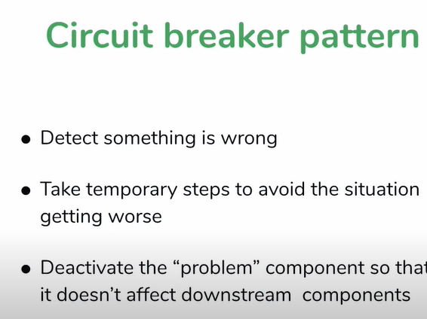

**What are circuit breaker in Microservices?**

The Circuit Breaker pattern is **a popular design pattern used in Microservices** Architecture, that falls under the Sustainable Design Patterns category. In Microservices architecture, a service usually calls other services to retrieve data, and there is the chance that the downstream service may be down.

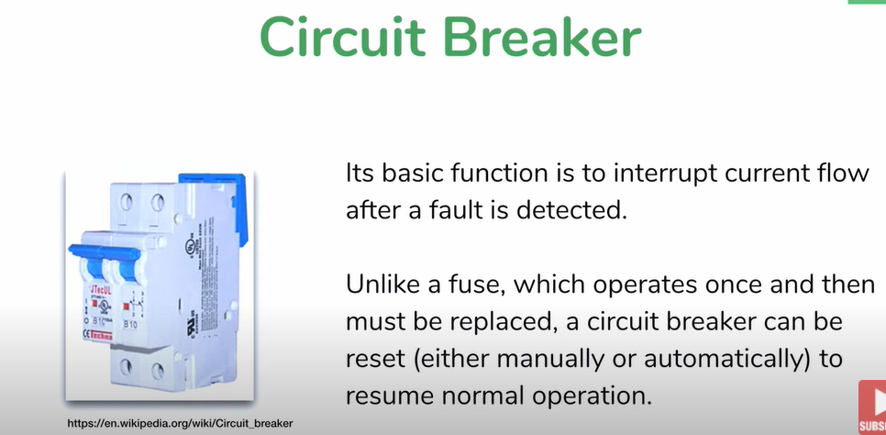

Note :--we can apply circuit breaker to every microservice that call other m/s

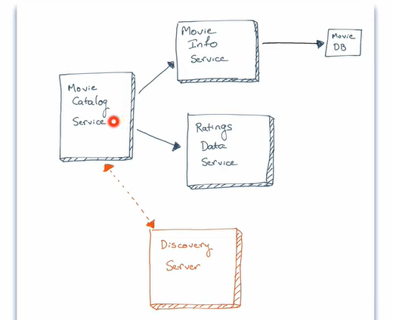

Note : **circuit breaker will apply for movie catlaog service if movie info service is slow**

**Circuit breaker parameter**

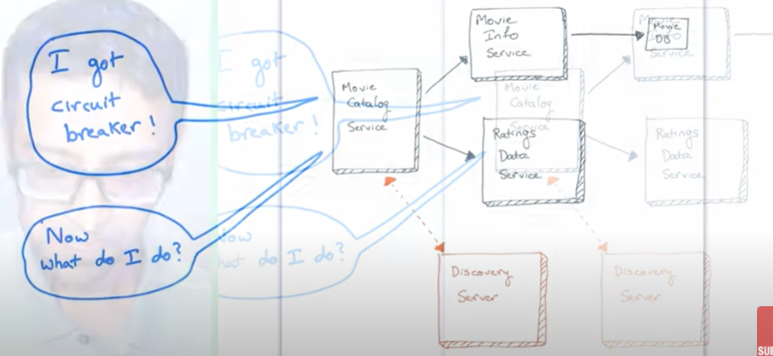

**Note:-**

If circuit breaker found M/S need to send back something

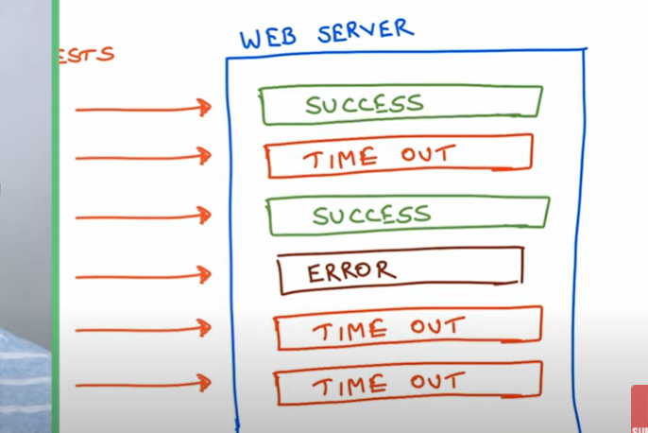

If at any point of time last three request is time out then circuit break is going to happen that one way is doing it

**Note :-**

this also we can't do . Let take a scenario one success and one failure then ciruit break will never happen

**NOTE :-** we need to know what is the parameter for circuit break

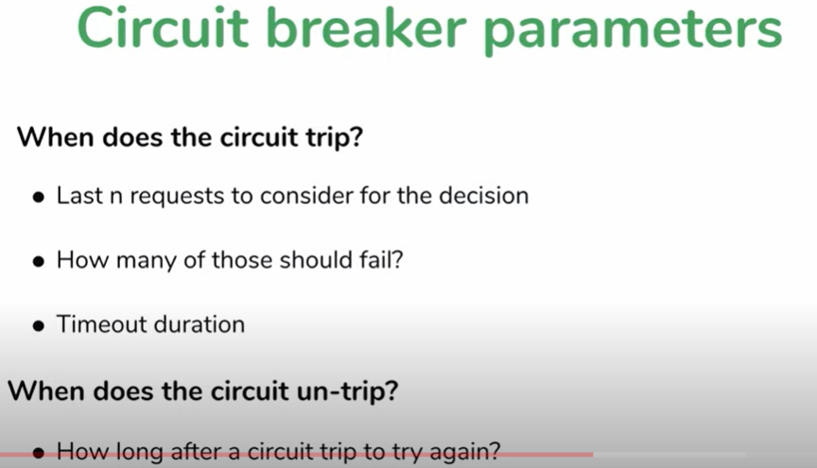

Once the circuit breaker occur then M/S will

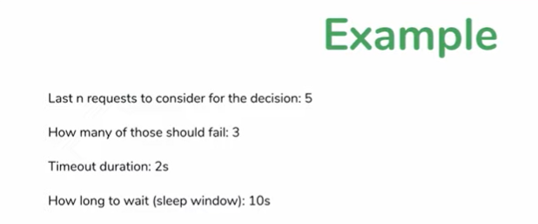

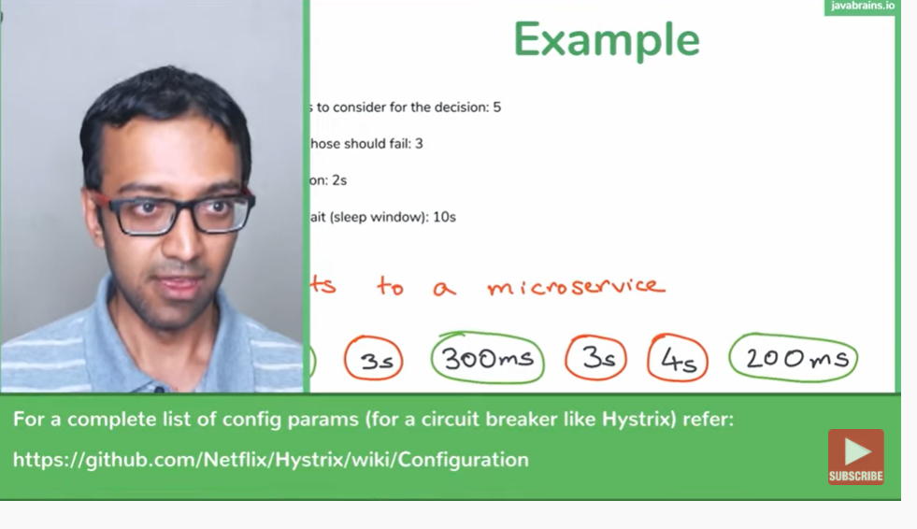

**What to do when circuit break**



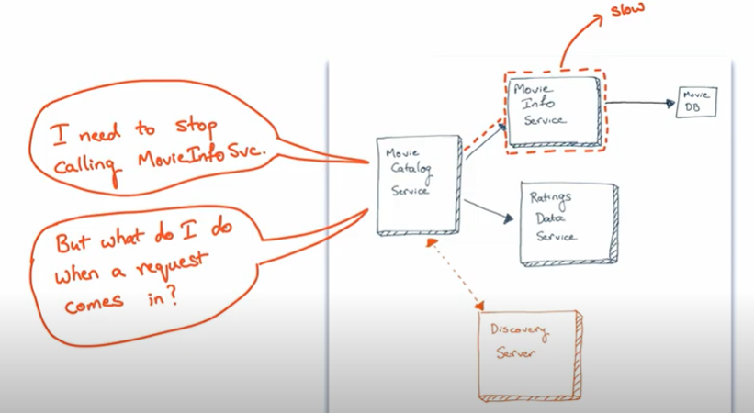

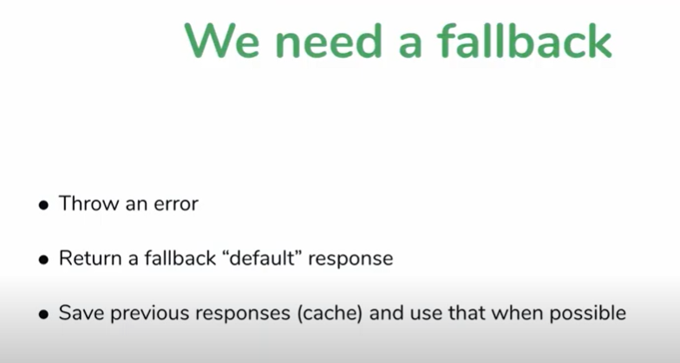

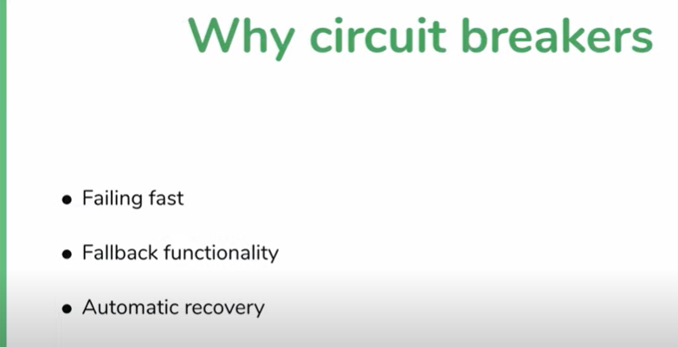

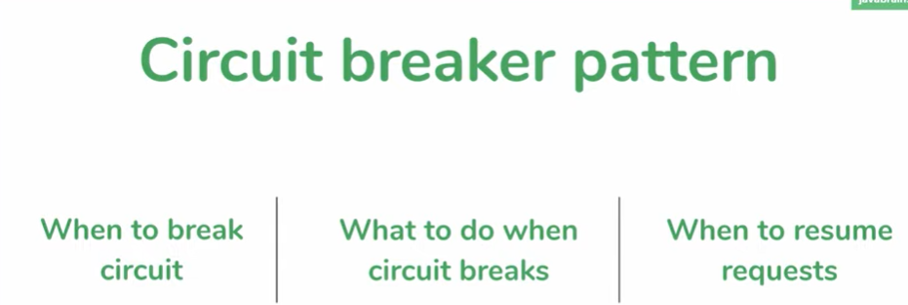

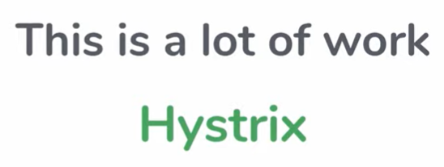

This is a lot of work we can resolve using Hystrix



**Hystrix**

**We need to give parameter to trip and get back again**

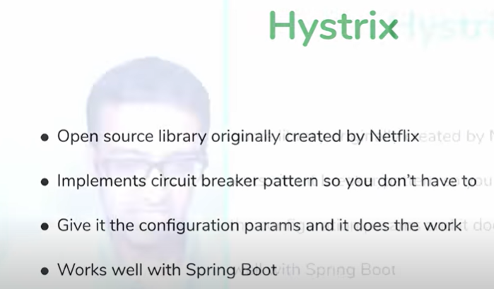

**Adding hystrix to spring boot M/S**

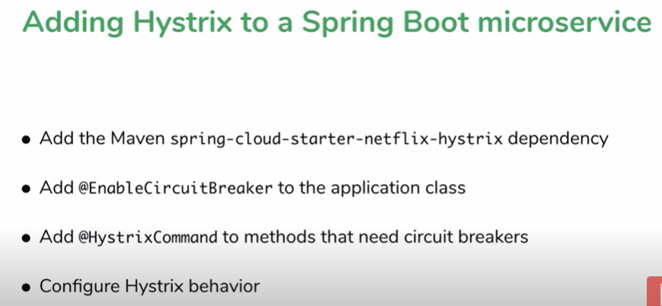

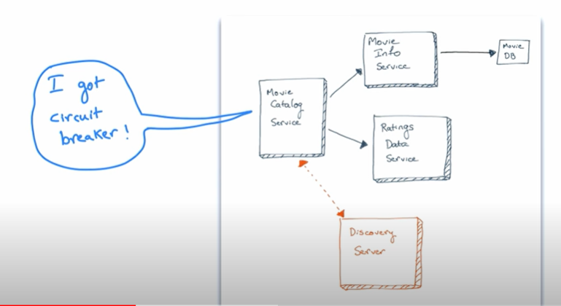

**Note :** will be adding circuit breaker in movie catalog service

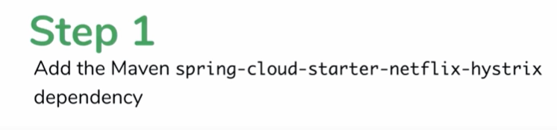

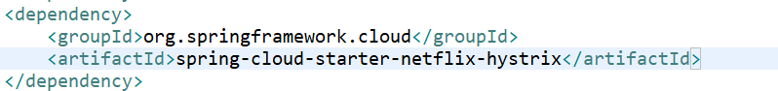

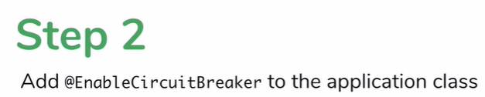

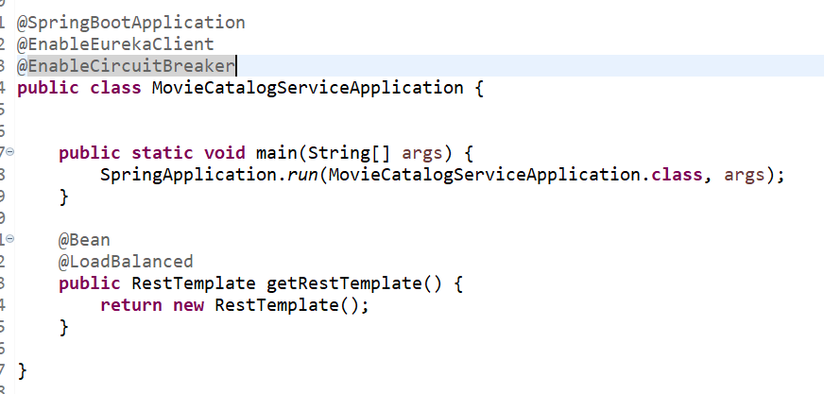

**By using @EnableCircuitBreaker** --- Hystrix enable but it doesn't know what to do (on what cause need to use circuit breaker)

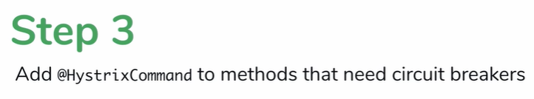

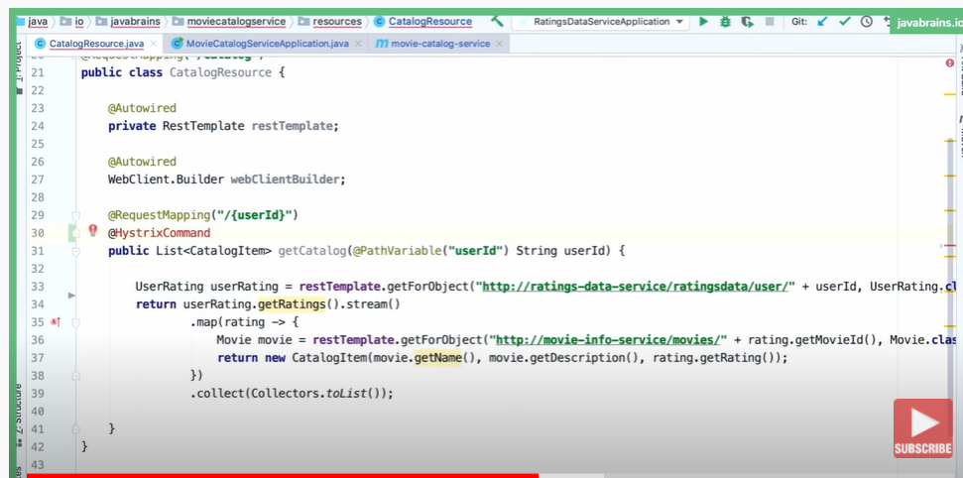

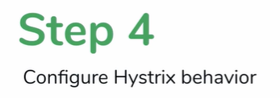

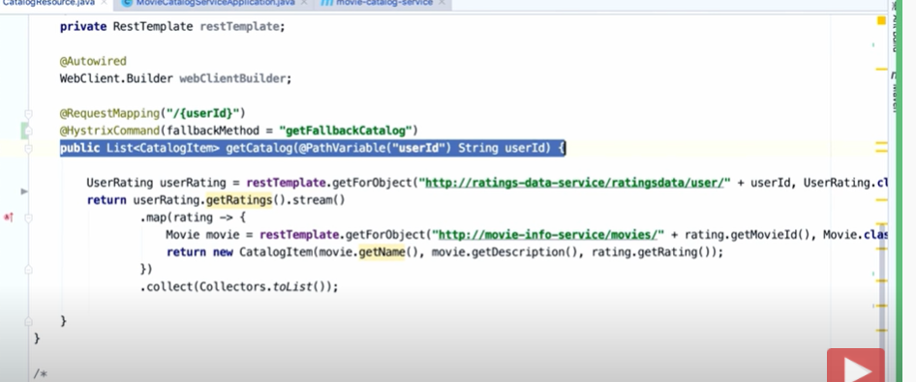

Note : hystrix telling when circuit breaker occur call getFallbackCatalogMethod

**If rating data microservice is down then will get**

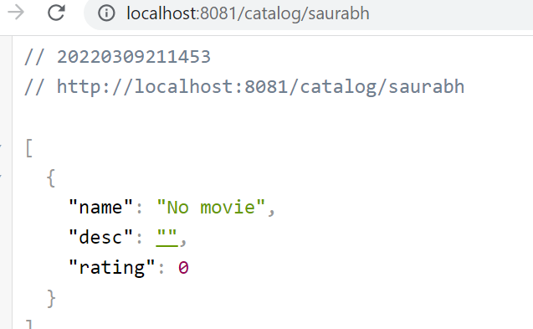

**Hystrix using fallback method when it detects service is down**

Problem with hystrix proxy



**Note:**

we have one method and calling two api service. If any one api is fails we have to break

The circuit

Note : we put hystrix on main method so if any one of M/s failed then it will call fallback method which is not ideal

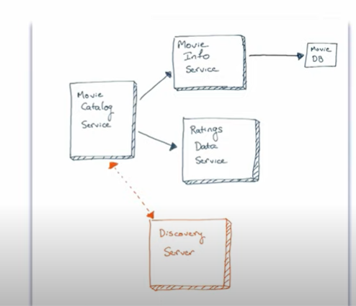

Note : going to enhance our code :

Movie-catalog -----write two method one will

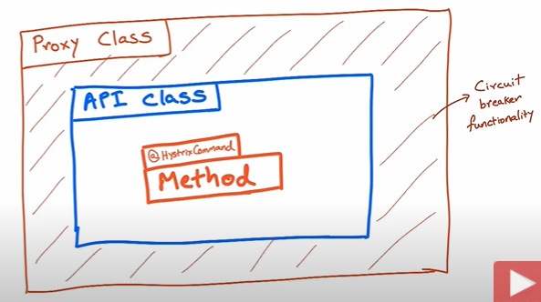

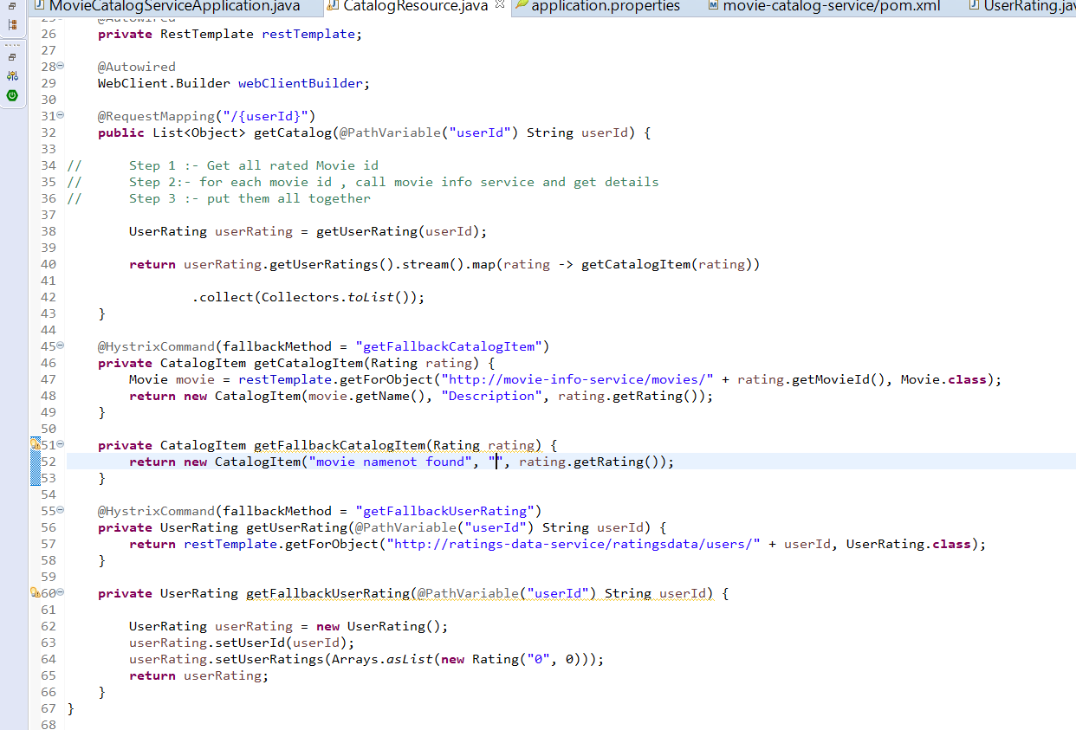

Proxy class will create who is calling the method which is having hystrix command.

It will not run because inside method only it calling hystrix method which is not able to intercept proxy class. The only way to run separate out call back method in another class

**NOTE**

If a method of hystrix within same class hystrix is not going to work

Refactor for granular feedback

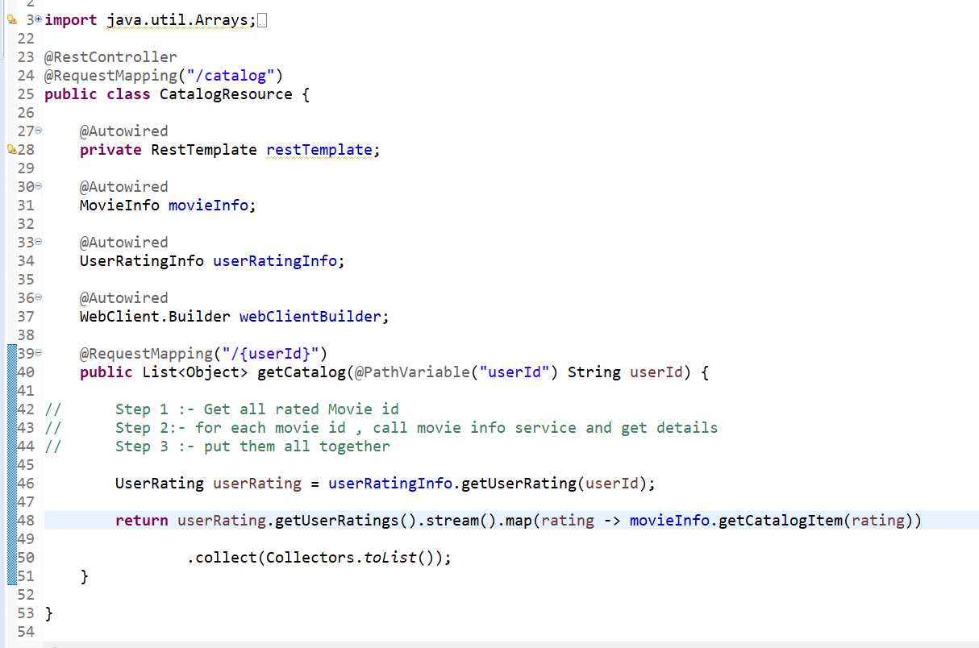

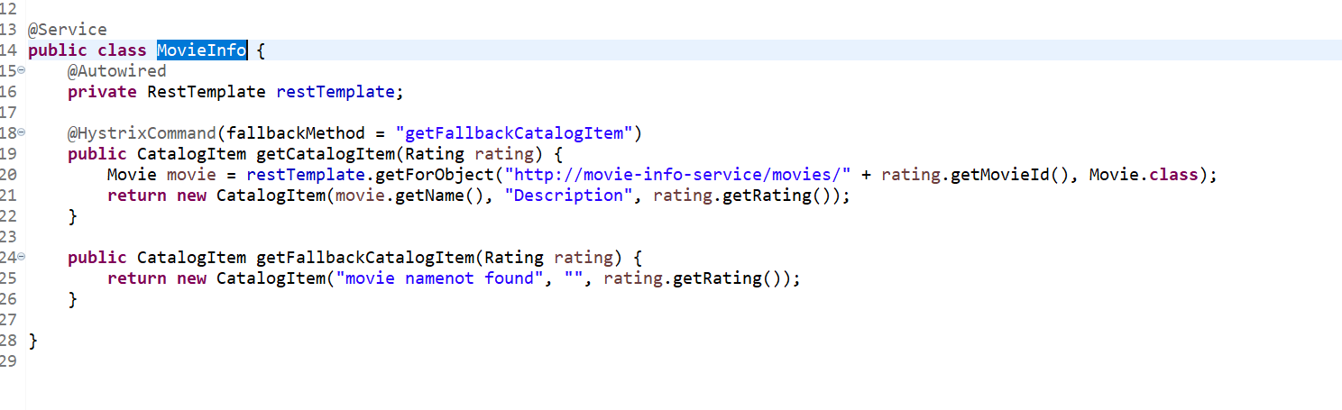

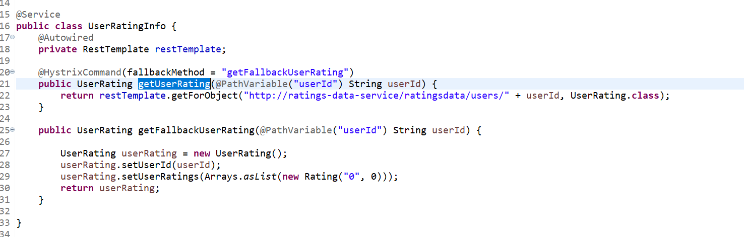

Configuring hystrix parameter

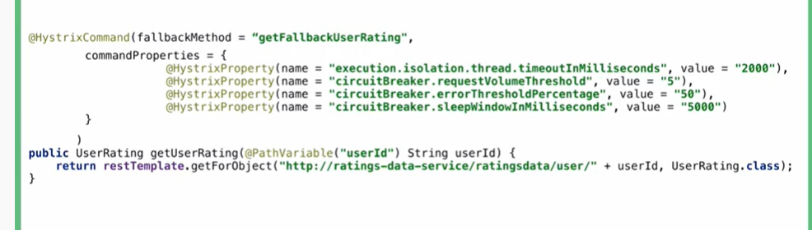

1. No of request
2. No of percentage of request failed
3. How long circuit breaker is sleep before it awake again

Hystrix dashboard

The ability to provide data in dashboard.

It will display circuit breaker in system(open,closed )

**One of the main benefits of Hystrix is the set of metrics it gathers about each HystrixCommand. The Hystrix Dashboard displays the health of each circuit breaker in an efficient manner.**

Note : we can setup hystrix dashboard for mutiple microservice or single microservice also

**Step 1: adding dependency in pom.xml**

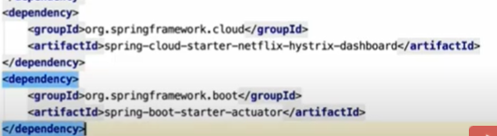

Step 2 : add annotation --EnableHystrixDashboard

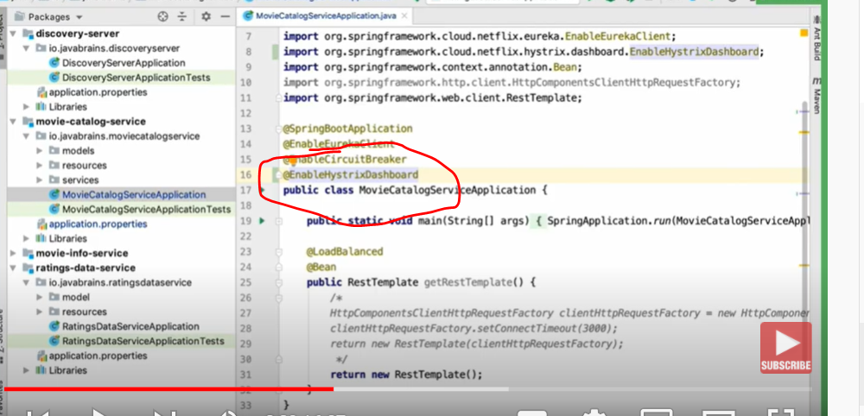

Step -3

Add this in application.properties

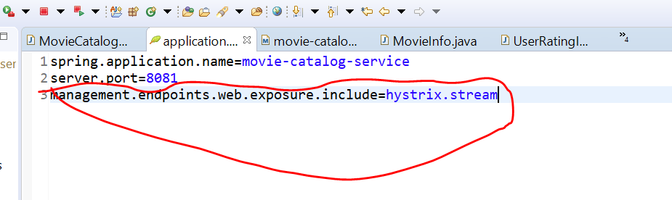

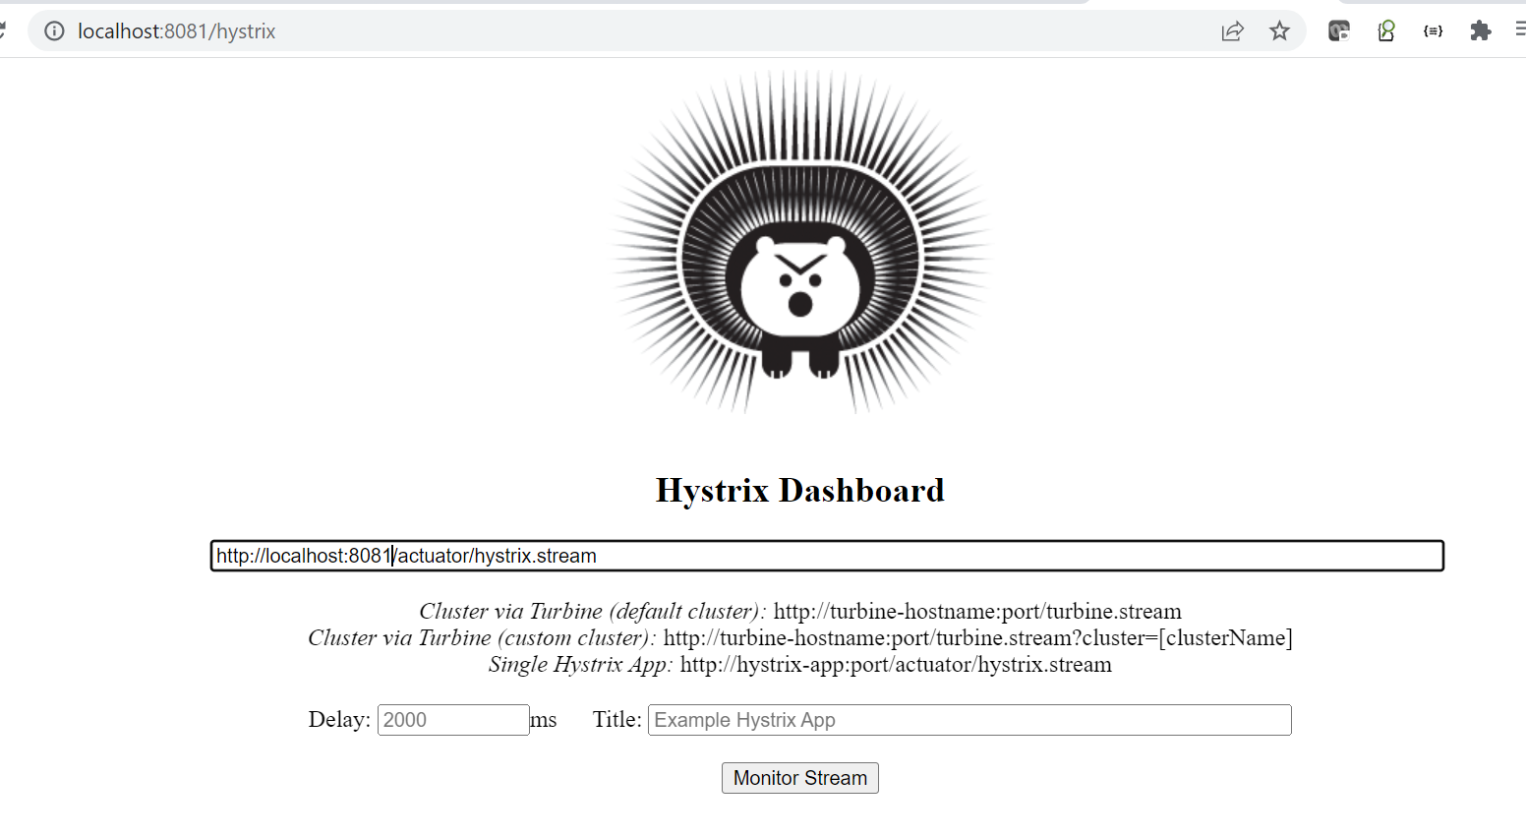

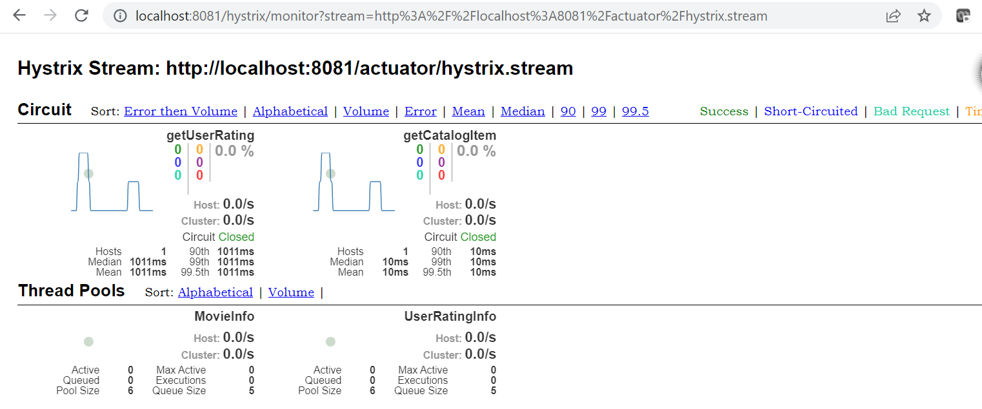

**The Bulkhead pattern**

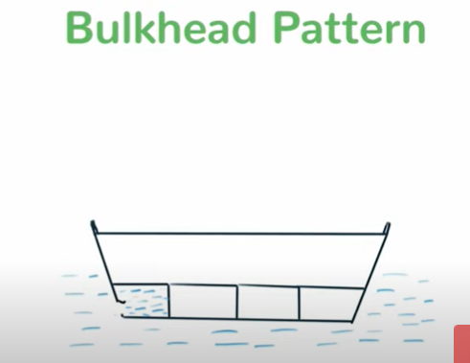

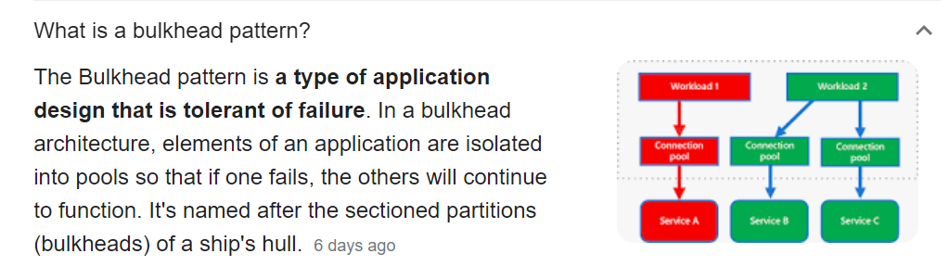

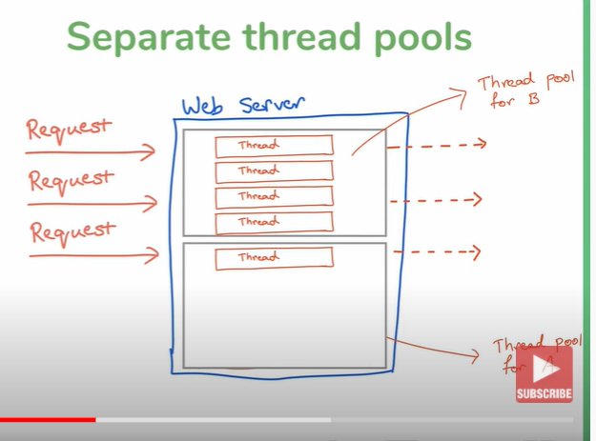

**Note : create separate threadpool for b and separate threadpool for A**

**We can configure this pattern with hystrix command in circuit breaker-------imp**

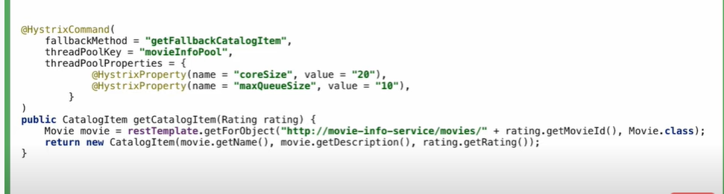

**Note :**

we can reuse same threadPooolKey for different method or we have individual

threadPoolKey for different method

Maximum 20 thread can be allow and in queue 10 request will be there which will wait for thread

